1. Analysis of the Size

The size of the merge area can be determined by the following parameters:

·Total width of typical toll lanes ().

·Length of the recovery zone ().

·Length of total departure zone().

·Width of the exit().

Parameters hereinbefore are shown in Figure 1.

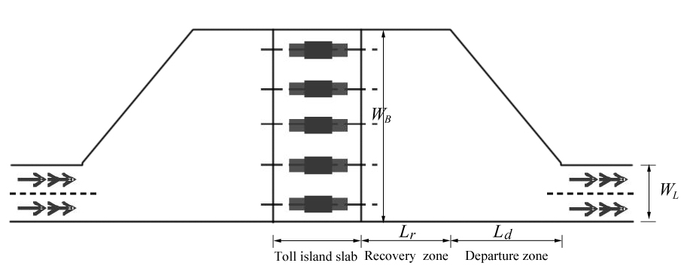

Figure 1

For the number of travel lanes () is fixed, is constant. Here we are going to consider the effect of the rest parameters separately. By simulating of our model mentioned above, we can find out how those parameters affect maximal throughput of merge area, that is, .

Figure 2 shows the changing trend of with the alteration of the width of each tollbooth, which can be describe as . Apparently = B. In Figure 2, ranges from 6 to 14 and other parameters are fixed.

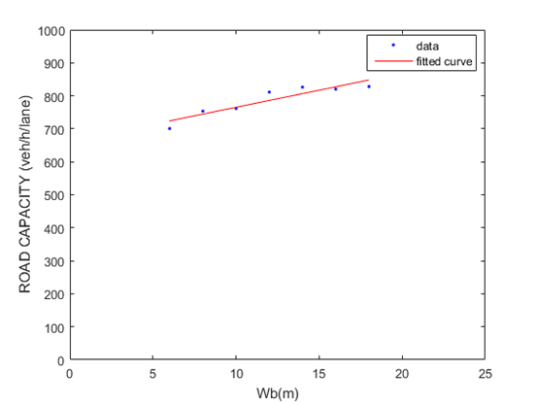

Figure 2

Furthermore, we can use the Fit Function Model to fit the data, so as to get the Linear Fitting Function of and as shown below:

=10.35

= 661.7

The simulation result indicates that would be affected by the total width of typical toll lanes () in a small degree. However, increasing will result in a significant increase in construction costs.

For , the linear fitting image is showed in Figure 3 and the variance of the set of is 36.7188. We can see that nearly cause no effect to the merge area capacity.

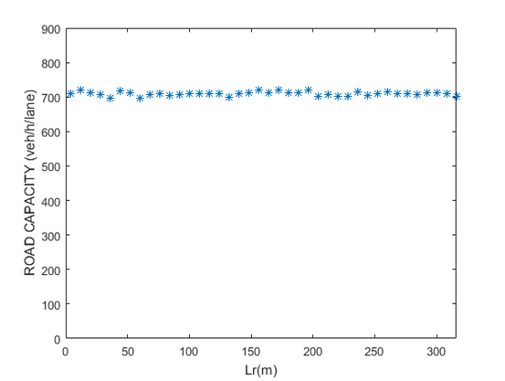

Figure 3 fitting image of Q3max and Lr

The linear fitting image and function of and are shown below. There is a negative correlation between and . Nevertheless, the relationship is so faintness that enlarging by changing is unrealistic.

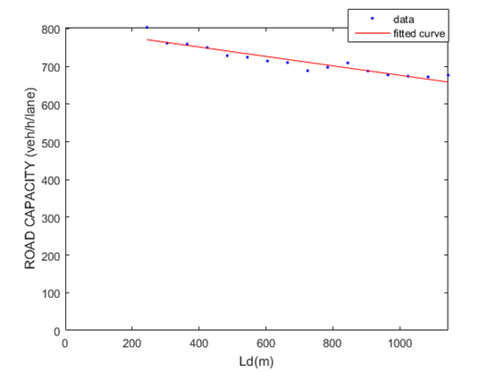

Figure 4 fitting image of Q3max and Ld

=-0.1248

= 801.1

From what has been discussed above, the size cause impact on , while the impact is faintness. While and should never be established too little because that may cause safety problem and result in higher accident rate. We will discuss this problem later in Chapter XX.

1. shape

We propose two types of the plaza shape: series type and parallel type.

1. Series type.

That is to say, connect two merge area in series. Take B is equal to eight and L is equal to three as an example. Vehicles fan in from eight tollbooth egress lanes down to six lanes of traffic, then fan in from six lanes of traffic to three, as Figure 7 shows. 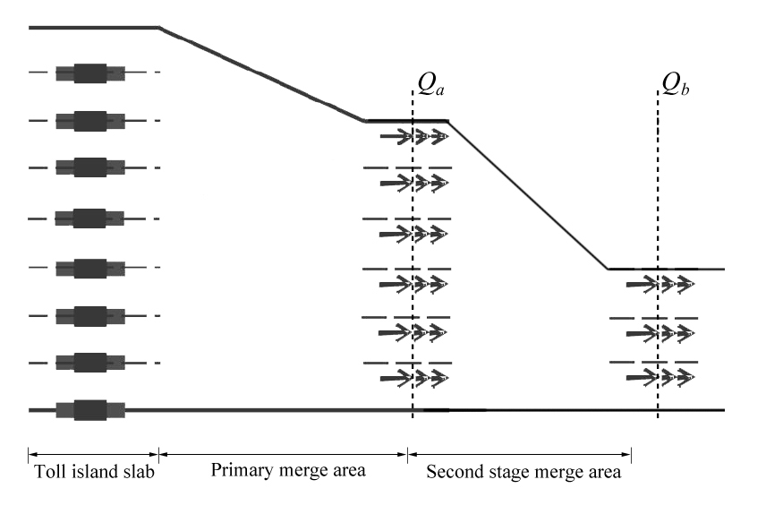

Figure 7 Series type

According to Buckets effect,

, and respectively signify the maximal throughput of the primary merge area, second stage merge area and the whole series-type toll plaza.

From simulation we get Table 1 which shows the value of the maximal throughput for each traffic line with different B and L (B>L).

|  |  |  |  |  |  |  |  |  |  |  |
| --- | --- | --- | --- | --- | --- | --- | --- | --- | --- | --- |
|  | B=1 | B=2 | B=3 | B=4 | B=5 | B=6 | B=7 | B=8 | B=9 | B=10 |
| L=1 |  | 882 | 845 | 832 | 796 | 771 | 772 | 736 | 689 | 640 |
| L=2 |  |  | 815 | 789 | 773 | 755 | 720 | 718 | 686 | 659 |
| L=3 |  |  |  | 755 | 758 | 734 | 724 | 709 | 684 | 671 |
| L=4 |  |  |  |  | 724 | 700 | 715 | 695 | 694 | 673 |
| L=5 |  |  |  |  |  | 716 | 695 | 690 | 688 | 673 |
| L=6 |  |  |  |  |  |  | 695 | 688 | 682 | 667 |
| L=7 |  |  |  |  |  |  |  | 682 | 676 | 670 |
| L=8 |  |  |  |  |  |  |  |  | 676 | 660 |
| L=9 |  |  |  |  |  |  |  |  |  | 651 |

table 1

For the example showed in Figure 7,

For a toll plaza whose merge area is simple with the same number of B and L,

Therefore

Furthermore, since is becoming large with the decreasing of B or L, we can prove that for any B and L, the merge area with portions in series would have a larger capacity. Thus, connecting two merge area in series is a practical and optimized scheme.

2) Parallel type

That is, divide the merge area transversely and put them together in parallel. For example, when B is equal to eight and L is equal to three, the toll plaza can be divided into two portions as Figure 8 shows.

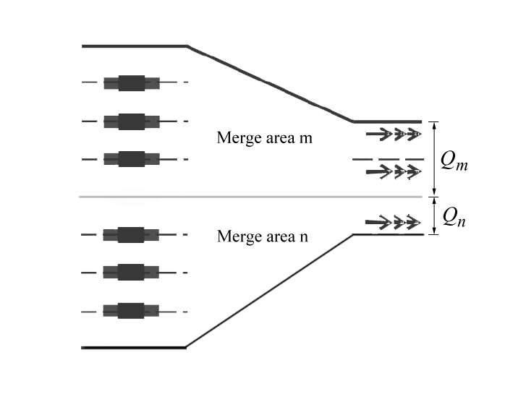

Figure 8 Parallel type

Since the two areas are juxtaposed,

, and respectively signify the maximal throughput of merge area m, merge area n and the whole parallel-type toll plaza.

Similar to the analysis of the series type, is becoming large with the increasing of B or L. Thus, this solution could enlarge the maximal throughput efficaciously.

1. Conclusion

Based on the above analysis, both series type and parallel type can contribute to the enlarging of , which lead to the result that when we would like to resolve throughput issues, it is practical to design its shape as series type or parallel type.